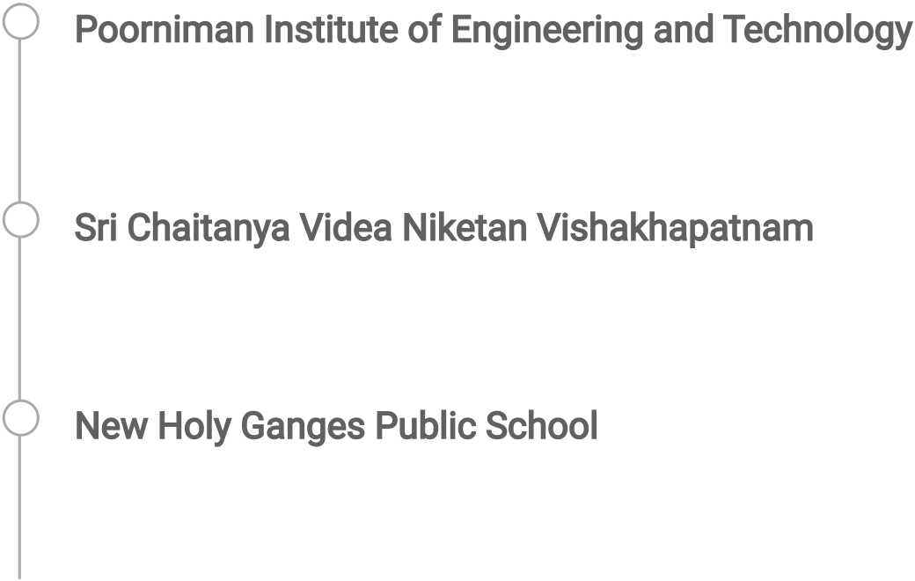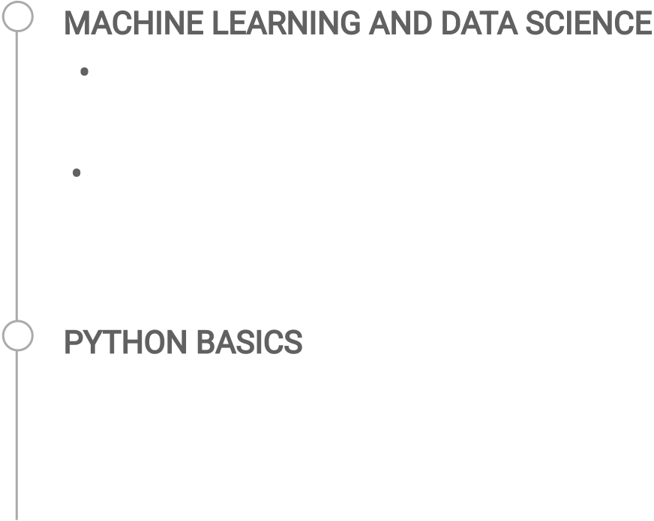

|  |  |  |
| --- | --- | --- |
|  | ISHU KUMAR | |
| 2020pietcsishu80@poornima.org 7004718739  RICCO Institutionals Area , Sitapur | |  Objective  As a computer science student , set to graduate in [2024]. With a strong passion for technology and programming, I has developed |
| a Jaipur 302022 | | a diverse set of skills in various programming languages And |
|  Skills | | Throughout their studies, i has been involved in a number of  projects including [ML , python ,Java ] Currently, I am seeking opportunities to apply am skills and continue to grow in the field of |
| C , C++ , Java , Python , ML , Kali | | computer science. |
| Linux , Data base , HTML | |  Education |

Poorniman Institute of Engineering and Technology   
Bachelor of Technology 2024 9.02

Sri Chaitanya Videa Niketan Vishakhapatnam 2019 12th   
64.6

New Holy Ganges Public School 2017 10th   
80

 INTERNSHIP

MACHINE LEARNING AND DATA SCIENCE   
 • Poornima Institute of engineering and technology in   
Association with Upflairs Pvt Ltd and xpecto IIT Mandi  
 • Built project using machine learning algorithm and deployed on heroku and stream lit

PYTHONBASICS   
 • Course Certificate on Coursera  
 • Built a project in python

 Experience

|  |  |  |
| --- | --- | --- |
|  | ML | 27/06/2022 |
| • I have Join as intern in Upflair which is | - 06/07/22 |
| associated with poornima institute of engineering and technology and xpecto IIT Mandi .  • In addition to my studies, i has also gained experience through Upflair, where i worked as learner . | |

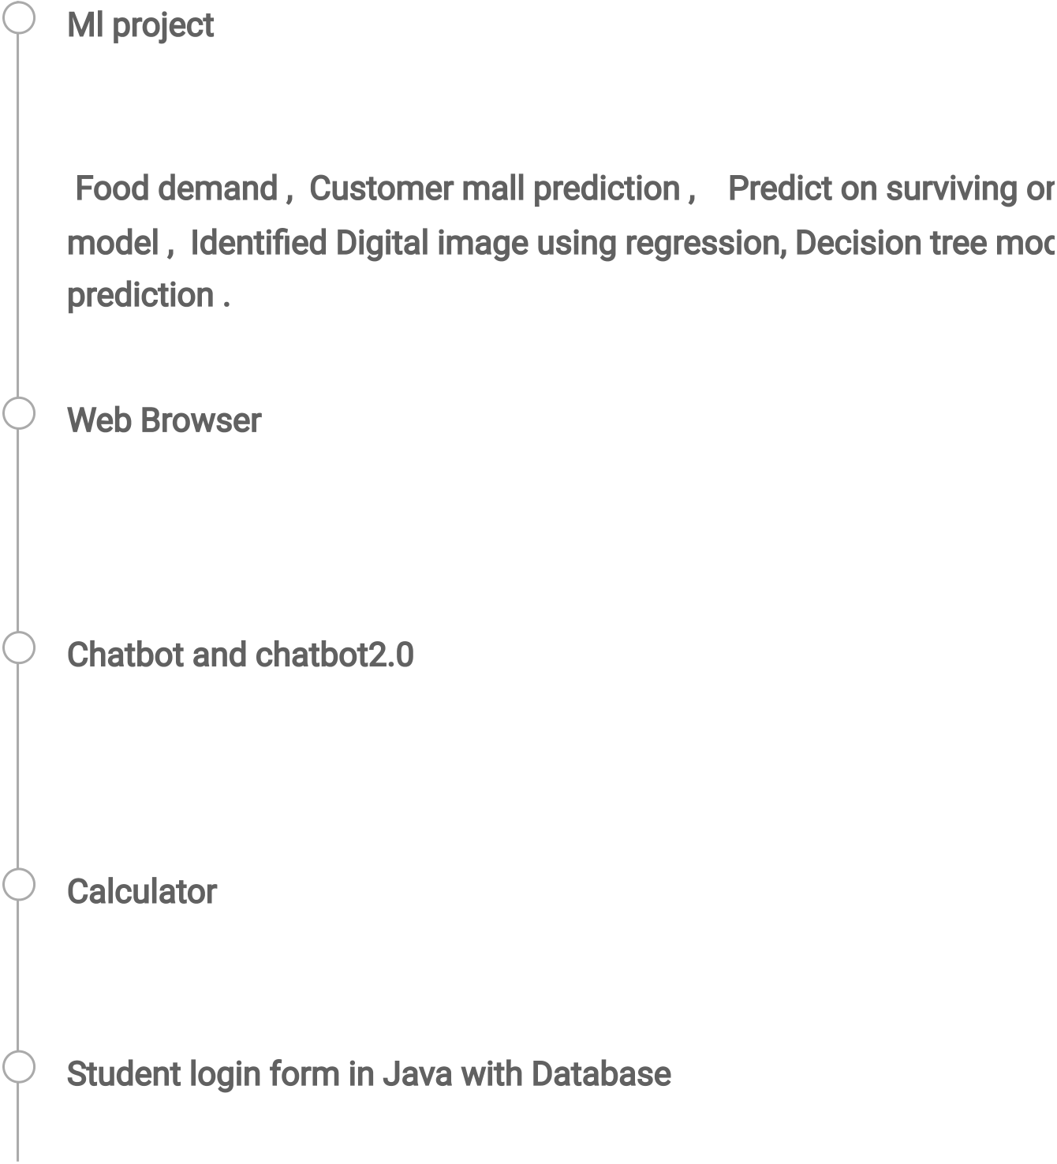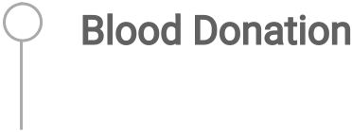

 Projects

Ml project   
I have made more than 10 ML project , web based applications whic system ,such as   
 Food demand , Customer mall prediction , Predict on surviving on model , Identified Digital image using regression, Decision tree mod prediction .

Web Browser   
It is based on python.

I have developed a web search engine.

Chatbot and chatbot2.0   
I have made a web based applications chatbot on using NLP algo . And another one is advance version on chatbot .

Calculator   
In python i have made calculator, which also calculated the advance

Student login form in Java with Database   
In this we can add the students data , such as userid and password

 Achievements & Awards

|  |  |
| --- | --- |
|  | I have enthusiastically completed 3 day hand on workshop on ETHIC Summer Internship on ML AND DATA SCIENCE .  NPTEL Certificate on Programming in Java . Microsoft Azure Data Fundamentals . |

 WORKSHOP

 Participate in Game Development

 PUBLICATION

Blood Donation  
• On the pandamic we have research that who can donate the blood